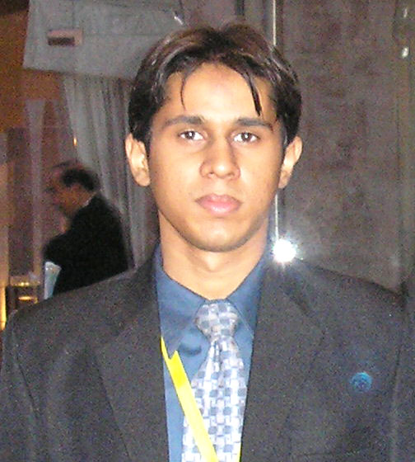
UBEDULLAH ANSARI

A-30 Memon Nagar Qasimabad
Hyderabad, Sindh, pakistan.
Email: ubed_ansari@spemail.org, jani_ansari@hotmail.com
Cell No: +92-334-2046861
Objective:
A target oriented and optimization based science professional, seeking an opportunity to utilize career experience, skills and education devoted to stabilize production and ultimate profitability.

Professional Experience :

- Currently working as Lecturer with Mehran University Of Engineering & Technology
- Subjects taught include, Reservoir Engineering, Corrosion Engineering & Environment & Safety Management
- Currently also serving as faculty Sponsor SPE Mehran Student Chapter
- Experienced in organizing and hosting various conferences and workshops
- Two months internship at Kunnar Oil Field & LPG Plant, OGDCL 2010
- Served as treasurer for the tenure of 2009-2010 in SPE Mehran Student Chapter
- Good know how of managing account and expenditures
- Worked in attachment at drilling rig of OGDCl & NHEPL
- Good experience in mechanical design, FEA and CAD and petroleum softwares (Eclipse, IPM, Field Manager & Petral)

Publications:

- “Huge Methane in Thar Coal Beds…………..But no extraction” 2010
(Got 1st position in Sub Regional Student Paper Contest, Pakistan held at Mehran University of Engineering & Technology Jamshoro)

- Simulating Effect of Condensate Dropout on Productivity Losses in a Gas-Condensate Reservoir 2010
(Got 2nd Position in SPE-PAPG-ATC 2010, Islamabad)

- “Designing A Completely Clean Closed Circle For CBM Extraction in Favor Of Thar Platform” Presented in Sub Regional Student Paper Contest, at University of Engineering And Technology Lahore, Pakistan, January 2011

- “Reservoir’s pressure transient analysis through real-time computer ayalytical applications” paper short listed for PAPG-SPE ATC 2011, Islamabad

- “Environmental Approach of Micro-Hole Drilling Technology for Hydrocarbon Recovery using Micro Instrumentation” presented in “Energy & Environment sustainable development conference 2012” at Mehran UET, Jamshoro

Under Graduate Thesis:
- “Advanced Application of integrated drilling simulator for drilling oil and gas wells”
  - The thesis work was comprised of a hypothetical model of a well to decrease its cost, consumed time and optimize the drilling operation
  - In order to confirm the results drilling simulator was used and it revealed very promising results

Professional Associations:
- Member, Society of Petroleum Engineers (SPE) International.
- Member, Mehran Student Chapter, Society of Petroleum Engineers.

Education:

Bachelor & Post Graduate Diploma of Petroleum & Natural Gas Engineering from Mehran University of Engineering & Technology, Jamshoro, Pakistan.
Academic Records
Academics | Year | Grade
Secondary School Certificate Examination. | 2004 | 75.7% A
Higher Secondary Certificate Examination. | 2006 | 71.2% A
B.E petro: & N.Gas Engg: | 2010 | A
PGD leading to ME | 2012 | 78%

Computer Skills:
- Excellent knowledge of computer applications including MS Office.
- Computer Programming Languages C++
- Certified in AutoCAD 2D & 3D
- Certified in Introduction to Ansys 10.0
- Certified in MATLAB Fundamentals
- Certified in Primavera
- Certified in Solid Edge
- Certified in Computer Hardware (maintaining the computer)
- Good in FEA Mechanical softwares
- Good in operating simulators

Communication Skills:
- Excellent in reading, writing, talking and understanding English, Urdu, and Sindhi.

